**CP Club 365 Days Challenge**

**Programming language – C++**

**Problem Statement**

<https://www.codechef.com/problems/VALENTINE>

Git :- <https://github.com/Vedantbharad2603/CP_club_365_Days>

**Your Code**:

// 0x120Day of 0x365Days challenge

// VEDANT BHARAD

// 14-2-2023

#include <iostream>

using namespace std;

int main() {

    // your code goes here

    int t;

    cin>>t;

    while (t--)

    {

        int x,y;

        cin>>x>>y;

        cout<<x/y<<endl;

    }

    return 0;

}

**Output (Screen Shot)**:

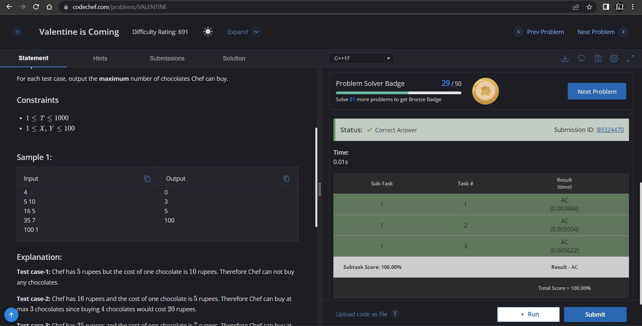

**Understanding about problem:**

* In this task I need to return number of chocolates chef can buy in given rupees.

Note: If you can't understand the problem, feel free to contact us and we'll help you. Please don't copy and paste from anywhere.

ALL THE BEST

Team CP Club